TABLE OF CONTENTS

Abstract 2
1 INTRODUCTION 3

  - GENERAL 3
  - THE IDEA 3
  - END USERS
  - USES & ADVANTAGES 4

- LITERATURE REVIEW 4

2.1 FEASIBILITY 4
2.2 TOOLS FOR IMPLEMENTATION 5

- CODES AND FUNCTIONAL UNITS 7

3.1 CONNECTION 8
3.2 BGTHREAD 10
3.3 XML PARSER 15
3.4 AUTO COMPLETE 22
3.5 PDF CREATOR 24
3.6 MAIN PAGE 28
  - LOGGING-IN 33

4 SCREEN-SHOTS 34

5 FUTURE ENHANCEMENTS 38

BIBLIOGRAPHY 39

ABSTRACT
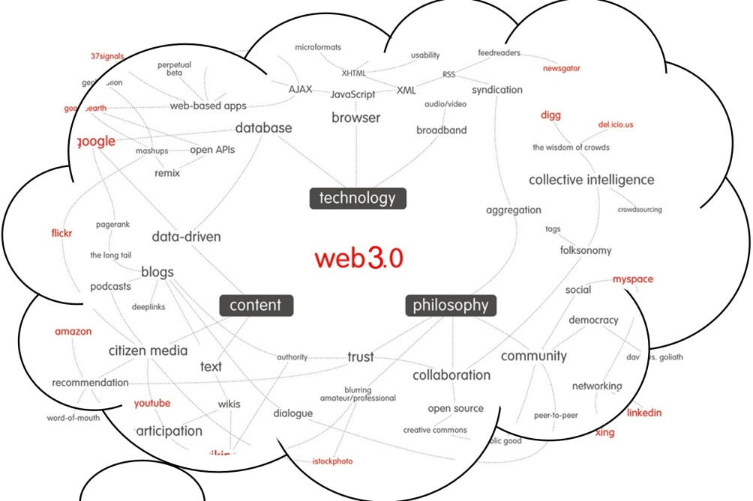
“ A tag cloud or word cloud (or weighted list in visual design) is a visual depiction of user-generated tags, or simply the word content of a site, typically used to describe the content of web sites. Tags are usually single words and are normally listed alphabetically, and the importance of a tag is shown with font size or color.^{[1]} Thus, it is possible to find a tag alphabetically and by popularity. The tags are usually hyperlinks that lead to a collection of items that are associated with a tag. Sometimes, further visual properties are manipulated, such as the font color, intensity, or weight.” - Wikipedia
A tag cloud is a way of jotting down key points in a cloud and using those points for reference to study. Our project aims at a way to automate the information retrieval process of a tag cloud with smart searching and a different look at the way the information is searched over the internet. We will represent our word database in a more creative and intelligent way. The student logs into his/her page and enters the tag words and in the background server all the information is retrieved and stored for future viewing by the student and his/her peers.

1 : INTRODUCTION
  - : GENERAL
- A tag cloud is a way of jotting down key points in a cloud and using those points for reference to study.
- Our project aims at a way to automate the information retrieval process of a tag cloud with smart searching and a different look at the way the information is searched over the internet. We represent our word database in a more creative and intelligent way.
- The student logs into his/her page and enters the tag words and in the background server all the information is retrieved and stored for future viewing by the student and his/her peers.
  - : THE IDEA
- The idea here is too make a data reference tag cloud for a student.
- The student logs on to the software and types in his keywords of the subject.
- The software retrieves the content in Wikipedia for the user’s keyword and stores it in his/her tag cloud.
- The student can then refer the tag cloud, add and delete more keywords.
- Finally the student can also convert his/her entire tag cloud in PDF for offline study.

  - : END USERS OF THIS SYSTEM
- The end users of this software are basically students and teachers.
- The students search and save data for their keywords while teachers can edit any information in data for each keyword as per technical needs.

  - :USES AND ADVANTAGES
- This software is extremely user friendly.
- It can be easily published as a website and can hence be used from anywhere.
- Students can have a ready-made QUESTION BANK to revise for tests/exams with regular and efficient use if this tool.
- Teachers can edit any keyword entry to suit curriculum needs.
- It is secure with each user having his/her own TAG CLOUD.
- Most frequent entries will exist in one common tag cloud.

- : LITERATURE REVIEW
  - :FEASIBILITY
Students often maintain a tag cloud in notebook for every subject. We have automated this service. This gives us opportunity to advertise the services to wider global audience. It can compete more effectively against larger, more well-known projects. The system tailored benefit service will allow you to obtain accurate and precise information regarding any benefit related queries.
  - :TOOLS FOR IMPLEMENTATION
JAVA/html/JavaScript/Jquery/etc. :-
- Java is a programming language originally developed by James Gosling at Sun Microsystems. The language derives much of its syntax from C and C++ but has a simpler object model and fewer low-level facilities. Java applications are typically compiled to byte code (class file) that can run on any Java Virtual Machine (JVM) regardless of computer architecture. Java is general-purpose, concurrent, class-based, and object-oriented, and is specifically designed to have as few implementation dependencies as possible. It is intended to let application developers "write once, run anywhere". Java is considered by many as one of the most influential programming languages of the 20th century, and is widely used from application software to web applications.
- HTML, which stands for Hypertext Markup Language, is the predominant markup language for web pages. It provides a means to create structured documents by denoting structural semantics for text such as headings, paragraphs, lists etc as well as for links, quotes, and other items. It allows images and objects to be embedded and can be used to create interactive forms. It is written in the form of HTML elements consisting of "tags" surrounded by angle brackets within the web page content. It can include or can load scripts in languages such as JavaScript which affect the behavior of HTML processors like Web browsers; and Cascading Style Sheets (CSS) to define the appearance and layout of text and other material.
- JavaScript is an object-oriented scripting language used to enable programmatic access to computational objects within a host environment. Although also used in other applications, it is primarily used in the form of client-side JavaScript, implemented as part of a web browser, providing enhanced user interfaces and dynamic websites. JavaScript is a dialect of the ECMA Script standard and is characterized as a dynamic, weakly typed, prototype-based language with first-class functions. JavaScript was influenced by many languages and was designed to look like Java, but to be easier for non-programmers to work with.
- jQuery is a lightweight cross-browser JavaScript library designed to simplify the client-side scripting of HTML. jQuery is free, open source software, dual-licensed under the MIT License and the GNU General Public License, Version 2. jQuery's syntax is designed to make it easier to navigate a document, select DOM elements, create animations, handle events, and develop Ajax applications. jQuery also provides capabilities for developers to create plug-ins on top of the JavaScript library. Providing this option, developers are able to create abstractions for low-level interaction and animation, advanced effects and high-level, theme-able widgets. This contributes to the creation of powerful and dynamic web pages.
- MYSQL
MySQL is a relational database management system (RDBMS) that runs as a server providing multi-user access to a number of databases. MySQL is officially pronounced /maɪˌɛskjuːˈɛl/ ("My S-Q-L"), but is often pronounced

/maɪˈsiːkwəl/ ("My Sequel"). It is named for original developer Michael Widenius's daughter My.

MySql is a great starter database for: Developers working on JAVA, PHP, .NET and Open Source applications DBAs who need a free, starter database for training and deployment and hardware vendors who want a starter database to distribute free of charge and educational institutes and students who need a free database for their curriculum.

- : CODES/FUNCTIONS
The main functional units of the software are:
- BG THREAD – the thread the word in the background for every user, retrieves and stores his/her information.
- XML PARSER – The function that extracts the useful units from the Wikipedia entry and leaves out the rest.
- PDF CREATOR – The function that creates a PDF for the user with his/her entire tag cloud on one click.
  - :CONNECTION BETWEEN FRONT END(JAVA) AND BACK END(MYSQL)
- First thing we need to do is establish connection to our Data Base.
- CODE :
package src;
import java.sql.*;
public class MySqlConnection {
static {
try {
DriverManager.registerDriver(new com.mysql.jdbc.Driver());
} catch (SQLException e) {
// TODO Auto-generated catch block
e.printStackTrace();
}
}
public static Connection getConnection() {
Connection conn = null;

try {

conn =
DriverManager.getConnection("jdbc:mysql://localhost/tagCloud?" +
"user=anto&password=dbms1");
} catch (SQLException ex) {
// handle any errors
System.out.println("SQLException: " + ex.getMessage());
System.out.println("SQLState: " + ex.getSQLState());
System.out.println("VendorError: " + ex.getErrorCode());
}
return conn;

}

public static void main(String[] args) throws Exception {
Connection c=getConnection();
System.out.println(c);
try {
Statement s=c.createStatement();
ResultSet r=s.executeQuery("select * from cloudwords");
while (r.next()) {
System.out.println(r.getString(1));
}
r.close();
s.close();
} finally {
c.close();
}}
}

  - : BG THREAD
package src;

import java.net.HttpURLConnection;
import java.net.URL;
import java.sql.*;
import java.util.*;

public class BgThread extends Thread {

Queue<String[]> wordinfo = new PriorityQueue<String[]>();
static BgThread bgThread = null;
static {
bgThread = new BgThread();
bgThread.start();
}

private BgThread() {

}

public static void add(String wordinfo, String user) {
synchronized (bgThread.wordinfo) {
bgThread.wordinfo.add(new String[] {wordinfo, user});
bgThread.wordinfo.notifyAll();
}
System.out.println("added " + wordinfo);

}

public void run() {
Connection c = antosrc.MySqlConnection.getConnection();
System.out.println(c);
try {
c.setAutoCommit(true);
} catch (SQLException e1) {
// TODO Auto-generated catch block
e1.printStackTrace();
}
while (true) {
String[] pname=null;

synchronized (bgThread.wordinfo) {
try {
bgThread.wordinfo.wait(10);
} catch (Exception e) {
}
pname = bgThread.wordinfo.poll();
}

if (pname != null){
c=antosrc.MySqlConnection.getConnection();
//System.out.println(c);
try {
String[] tokens = pname[0].split(", ");

for (String t : tokens) {
if(t.trim() != null){
String temp=t;
temp=temp.toLowerCase();
String spaceCheck="";
for(int i=0;i<t.length();i++){
if(temp.charAt(i) != ' ')
spaceCheck=spaceCheck+temp.charAt(i);
else
spaceCheck=spaceCheck+"_";
}
URL u = new URL("http://en.wikipedia.org/wiki/"+spaceCheck);
HttpURLConnection uc = (HttpURLConnection) u.openConnection();
int code = uc.getResponseCode();
String response = uc.getResponseMessage();
if(code!=404 && !(response.toLowerCase().contains("Not Found"))){
try {
Statement s=c.createStatement();
ResultSet r=s.executeQuery("select count(*) from words where word='"+t+"'");
r.next();
String query;

if(r.getInt(1)==0){
new XMLReader(spaceCheck);
query = "insert into words (word,refers) values('"+ t + "','" + spaceCheck + "')";
s = c.createStatement();
s.execute(query);
Statement s3=c.createStatement();
s3.execute("update words set added=1 where word='"+t+"'");
s3.close();
System.out.println(s);

}
else{
System.out.println("\nAlready added word!!");
}
Statement s1=c.createStatement();
ResultSet r1=s1.executeQuery("select count(*) from userwords where username='"+pname[1]+"' and word='"+t+"'");
r1.next();
if(r1.getInt(1)==0){
query="insert into userwords (username,word) values('"+pname[1]+"','"+t+"')";
s = c.createStatement();
s.execute(query);
query = "update words set count=count+1 where word='"+t+"'";
s = c.createStatement();
s.execute(query);
}
r1.close();
s1.close();

s.close();
}
finally {

}
}
else
System.out.println("Word Incorrectly Spelled!");

}
}
} catch (Exception e) {
System.out.println(e);
}
}
}
}

  - : XML PARSER
package src;
import java.io.*;
import java.net.*;
import java.sql.*;

public class XMLReader{

public XMLReader(String word) throws SQLException, IOException{

word=word.toLowerCase();

UrlText(word,0);

InputStream inp = new FileInputStream("c:/java-workspace/tagCloud/tagWords/"+word+".txt");
Reader rd = new InputStreamReader(inp);
int chr;
String entry="";
while((chr=rd.read())!=-1){
entry=entry+(char)chr;
}
System.out.print(entry);

//File f1=new File("C:/Users/Anto/Documents/tagCloud/"+word+".txt");
//f1.delete();
entry=entry.trim().toLowerCase();
System.out.println("...\n\n\n..."+entry+"...\n\n\n\n...");
if(entry.contains("may refer to")){
System.out.println("...\n\n\n...1"+entry+"1...\n\n\n\n...");
File f1=new File("c:/java-workspace/tagCloud/tagWords/"+word+".txt");
boolean success = f1.delete();
if (!success)
System.out.println("Delete: deletion failed");
String refer=word, temp=UrlText(word,1);
Connection c=antosrc.MySqlConnection.getConnection();
System.out.println(c);
try {
Statement s=c.createStatement();
String spaceCheck1="";
temp=temp.toLowerCase();
for(int i=0;i<temp.length();i++){
if(temp.charAt(i) != ' ')
spaceCheck1=spaceCheck1+temp.charAt(i);
else
spaceCheck1=spaceCheck1+"_";
}
s.execute("update words set refers='"+spaceCheck1+"' where word='"+refer+"'");
s.close();

} finally {
c.close();
}
new XMLReader(temp);

}

}

public String UrlText(String word, int referred) throws SQLException{
try{

URL u = new URL("http://en.wikipedia.org/wiki/"+word);
HttpURLConnection uc = (HttpURLConnection) u.openConnection();
int code = uc.getResponseCode();
String response = uc.getResponseMessage();
System.out.println("HTTP/1.x " + code + " " + response);
for(int j = 1; ; j++){
String header = uc.getHeaderField(j);
String key = uc.getHeaderFieldKey(j);
if(header == null || key == null)
break;
System.out.println(uc.getHeaderFieldKey(j) + ": " + header);
}
System.out.println("\n\n"+word+"\n\n");
InputStream in = new BufferedInputStream(uc.getInputStream());

OutputStream out = new FileOutputStream("c:/java-workspace/tagCloud/tagWords/"+word+".txt");

byte[] buf= new byte[1];
int len=1;
while (len > 0){
in.read(buf, 0, 1);
//System.out.print((char)buf[0]);
if((char)buf[0] == '<')
if(in.read(buf, 0, 1)>0 && (char)buf[0] == 'p')
break;
}
//System.out.println("...\n\n\n..."+(char)buf[0]+"...\n\n\n\n...");
if(referred==1){
String referTo="";
in.mark(500);
if(in.read(buf,0,1)>0 && (char)buf[0]=='>'){
//while(in.read(buf,0,1)>0 && (char)buf[0]!='<' && in.read(buf,0,1)>0 && (char)buf[0]!='l');
while(true){
if(in.read(buf,0,1)>0 && (char)buf[0]=='<')
if(in.read(buf,0,1)>0 && (char)buf[0]=='l')
if(in.read(buf,0,1)>0 && (char)buf[0]=='i')
break;
}
if(in.read(buf,0,1)>0 && (char)buf[0]=='>')
if(in.read(buf,0,1)>0 && (char)buf[0]=='<' && in.read(buf,0,1)>0 && (char)buf[0]=='a'){
while(in.read(buf,0,1)>0 && (char)buf[0]!='>');
while(in.read(buf,0,1)>0 && (char)buf[0]!='<')
referTo=referTo+((char)(buf[0]));
}
System.out.println("...\n\n\n...(r)"+referTo+"(r)...\n\n\n\n...");
}
in.reset();

return referTo;

}
int flag=1;
while (in.read(buf,0,1) > 0 && flag==1){
if((char)buf[0] != '<' && (char)buf[0] != '>' && (char)buf[0]!='[')
out.write(buf[0]);
if((char)buf[0] == '[')
while(in.read(buf,0,1)>0 && (char)buf[0]!=']');

if((char)buf[0] == '<' ){
in.mark(2);
if( in.read(buf,0,1)>0 && (char)buf[0]=='l' && in.read(buf,0,1)>0 && (char)buf[0]=='i' ){
out.write('-');

}
in.reset();
in.mark(4);
if( in.read(buf,0,1)>0 && (char)buf[0]=='<' && in.read(buf,0,1)>0 && (char)buf[0]=='/' && in.read(buf,0,1)>0 && (char)buf[0]=='p' && in.read(buf,0,1)>0 && (char)buf[0]=='>'){
flag=0;
break;
}
in.reset();
if( in.read(buf,0,1)>0 && (char)buf[0]=='h'){
flag=0;
break;
}
while(in.read(buf,0,1)>0 && (char)buf[0]!='>');
}

}

}
catch(MalformedURLException ex){
System.err.println("url is not a valid URL.");
}
catch(IOException ie){
System.out.println("Input/Output Error: " + ie.getMessage());
}
return "";
}

public static void main (String[] args) throws IOException, SQLException{
String word="monitor";

System.out.println("\n\n"+word+"\n\n");
new XMLReader(word);
}
}

  - AUTO COMPLETE : To facilitate intelligent auto-completion of words.
package src;

import java.sql.*;
import java.util.ArrayList;
import java.util.List;

public class AutoComplete {

private int totalWords;
private List<String> words;
public AutoComplete() throws SQLException {
words = new ArrayList<String>();
Connection c=antosrc.MySqlConnection.getConnection();
//System.out.println(c);
try {
Statement s=c.createStatement();
ResultSet r=s.executeQuery("select word from words");
while (r.next()) {
words.add(r.getString(1));
}
s.close();

} finally {

}
totalWords = words.size();
}

public List<String> getData(String query) {
String word = null;
query = query.toLowerCase();
List<String> matched = new ArrayList<String>();
for(int i=0; i<totalWords; i++) {
word = words.get(i).toLowerCase();
if(word.startsWith(query)) {
matched.add(words.get(i));
}
}
return matched;
}
}

  - :PDF CREATOR
package src;

import java.io.*;

import java.util.Date;
import java.sql.*;
import java.text.*;
import com.itextpdf.text.*;
import com.itextpdf.text.pdf.*;

public class PdfCreator {

public PdfCreator(String user, OutputStream out){

Document document = new Document(PageSize.A4, 50, 50, 50, 50);
try{
//PdfWriter writer = PdfWriter.getInstance(document, new FileOutputStream("tagWords/"+user+"'s1TagReference.pdf"));
PdfWriter writer = PdfWriter.getInstance(document, out);
Font wordFont = new Font(Font.FontFamily.TIMES_ROMAN, 12, Font.BOLD);
Font textFont = new Font(Font.FontFamily.TIMES_ROMAN, 11, Font.NORMAL);
document.open();
Connection c=antosrc.MySqlConnection.getConnection();
System.out.println(c);
(new Paragraph("")).setAlignment(0);
document.add(new Paragraph(""));
document.add(new Chunk(user.toUpperCase()+"'s TAG REFERENCE", new Font(Font.FontFamily.TIMES_ROMAN, 18, Font.BOLD)).setUnderline(0.2f, -2f));
document.add(new Chunk(" ("+(DateFormat.getDateInstance(DateFormat.LONG)).format(new Date())+")"));
document.setMargins(50,50,49,10);
try {
Statement s=c.createStatement();
ResultSet r = s.executeQuery("select * from words where word in (select word from userwords where username='"+user+"')");
while(r.next()){
document.add(new Chunk("\n\n"));
document.add(((new Chunk(r.getString(1)+" :- ", wordFont)).setUnderline(0.2f, -2f)));
document.add(new Chunk(" "));
File f= new File("c:/java-workspace/tagCloud/tagWords/"+r.getString(4)+".txt");
System.out.println(f.exists()+"\t"+f.getAbsolutePath());
InputStream inp = new FileInputStream(f);
Reader rd = new InputStreamReader(inp);
int chr;
while((chr=rd.read())!=-1 && (char)chr != '\n'){
String word="";
do{
if((char)chr == '&'){
while((chr=rd.read())!=-1 && (char)chr != ';');
word=word+' ';
}
else{
word=word+(char)chr; }

}while((chr=rd.read())!=-1 && (char)chr != ' ' && (char)chr != '\n');
System.out.print(word);
if(word.equalsIgnoreCase(r.getString(1)))
document.add(new Chunk(word, wordFont));
else
document.add(new Chunk(word, textFont));
document.add(new Chunk(' '));
System.out.print((char)chr);
}
document.setMarginMirroring(true);

}
s.close();

} finally {
c.close();
}

document.close();
} catch (Exception e){
System.err.println(e.getMessage());
}

}
public static void main(String[] args) {
new PdfCreator("anto",System.out);
}

}

  - :MAIN PAGE

<%@ page language="java" contentType="text/html; charset=ISO-8859-1"
- pageEncoding="ISO-8859-1"%>
- <%@page import="java.sql.*,antosrc.*,java.io.*,java.util.Random" %>
- <!DOCTYPE html PUBLIC "-//W3C//DTD HTML 4.01 Transitional//EN" "http://www.w3.org/TR/html4/loose.dtd">
- <html>
- <head>
- <meta http-equiv="Content-Type" content="text/html; charset=UTF-8"/>
- <title>Tag Cloud</title>
- <style type="text/css" media="screen">
- #tagcloud {
- width: 600px;
- background:#FFFFCC;
- color:#0066FF;
- padding: 16px;
- border: 1px solid #FFE7B6;
- text-align:center;
- position: absolute;
- top: 50%;
- left: 50%;
- margin-top:-200px;
- margin-left:-400px;

- }

- #tagcloud a:link, #tagcloud a:visited {
- text-decoration:none;
- }

- #tagcloud a:hover, #tagcloud a:active {
- text-decoration: underline;
- color: black;
- }

- #tagcloud span {
- padding: 8px;
- }

- </style>
- <style type="text/css">

- .glidetext{
- position: relative;
- /*Set initial position of your text. Make it just enough to hide the text from view:*/
- left: -500px;
- }

- </style>
- <script type="text/javascript">

- //Sequential fly-in text script- by JavaScriptKit.com
- //For this script and 400+ more, visit http://www.javascriptkit.com
- //This notice must stay intact for use

- var pausebetweenmsg=1;//customize pause in miliseconds between each message showing up (3000=3 seconds)
- var glidespeed=500; //customize glide speed in pixels per frame.

- var curobjindex=0;

- function actualstyle(el, cssproperty){
- if (el.currentStyle)
- return el.currentStyle[cssproperty];
- else if (window.getComputedStyle){
- var elstyle=window.getComputedStyle(el, "");
- return elstyle.getPropertyValue(cssproperty);
- }
- }

- function collectElementbyClass(){
- var classname="glidetext";
- glidearray=new Array();
- var inc=0;
- var alltags=document.all? document.all : document.getElementsByTagName("*");
- for (i=0; i<alltags.length; i++){
- if (alltags[i].className==classname)
- glidearray[inc++]=alltags[i];
- }
- if (glidearray.length>0)
- onebyoneglide();
- }

- function onebyoneglide(){
- if (curobjindex<glidearray.length)
- glidetimer=setInterval("glideroutine()",5);
- }

- function glideroutine(){
- if (parseInt(actualstyle(glidearray[curobjindex], "left"))<0)
- glidearray[curobjindex].style.left=parseInt(actualstyle(glidearray[curobjindex], "left"))+50+"px";
- else{
- glidearray[curobjindex].style.left=0;
- curobjindex++;
- clearInterval(glidetimer);
- setTimeout("onebyoneglide()", pausebetweenmsg)
- }
- }

- if (window.addEventListener)
- window.addEventListener("load", collectElementbyClass, false);
- else if (window.attachEvent)
- window.attachEvent("onload", collectElementbyClass);
- else if (document.getElementById)
- window.onload=collectElementbyClass;
- </script>
- <script>
- function wikiInfo(f)
- {
- document.getElementById("wikiFrame").style.visibility="visible";
- document.getElementById("wikiFrame").width="300";
- document.getElementById("wikiFrame").height="100";
- document.getElementById('wikiFrame').style.position="absolute";
- document.getElementById('wikiFrame').style.left=event.clientX-10;
- document.getElementById('wikiFrame').style.top=event.clientY-10;
- document.getElementById("wikiFrame").src="wordInfo.jsp?word="+f;

- if(f=='a')
- document.getElementById("wikiFrame").style.visibility="hidden";

- }
- </script>
- </head>
- <body>

- <div id="tagcloud">
- <table border="0" bgcolor="white" align="right">

- <form method="POST" action="loginproc.jsp">
- <tr><td>Username</td><td>:</td><td><input type="text" name="username" size="20"></td></tr>
- <tr><td>Password</td><td>:</td><td><input type="password" name="password" size="20"></td></tr>
- <tr><td>&nbsp;</td><td>&nbsp;</td><td>&nbsp;&nbsp;&nbsp;&nbsp;&nbsp;&nbsp;&nbsp;&nbsp;&nbsp;&nbsp;&nbsp;&nbsp;&nbsp;&nbsp;&nbsp;&nbsp;<input class="button" type="submit" value="Login" /></td></tr>
- </form>
- </table>
- <br><br><br><br><br>

- <%

- Connection c=antosrc.MySqlConnection.getConnection();
- String[] strArr;
- int[] cntArr;
- int numberPerLine=5;
- try {
- Statement s = c.createStatement();
- ResultSet r = s.executeQuery("SELECT count(word) FROM cloudWords ORDER BY count DESC");
- r.next();
- strArr=new String[r.getInt(1)]; // create empty array
- cntArr=new int[r.getInt(1)];
- r.close();
- s.close();
- }
- finally{

- }
- int maximum = 0; // $maximum is the highest counter for a search term
- int pos=0;

- try {
- Statement s = c.createStatement();
- ResultSet r = s.executeQuery("SELECT word,count FROM cloudWords ORDER BY count DESC");

- while (r.next()){
- String word = r.getString("word");
- int count = r.getInt("count");

- // update $maximum if this term is more popular than the previous terms
- if (count> maximum)
- maximum = count;

- cntArr[pos]=r.getInt("count");
- strArr[pos++]=r.getString("word");
- }
- r.close();
- s.close();
- }
- finally{
- c.close();
- }
- int N = strArr.length;
- int lines=0;
- for (int i = 0; i < N; i++) {
- int random = i + (int) (Math.random() * (N-i)); // between i and N-1
- String swapStr = strArr[i];
- int swapCnt = cntArr[i];
- strArr[i] = strArr[random];
- cntArr[i] = cntArr[random];
- strArr[random] = swapStr;
- cntArr[random] = swapCnt;
- }

- for(int i=0;i<N;i++){
- int size=0;
- if(cntArr[i] < 5)
- size=10;
- else if(cntArr[i] < 10)
- size=14;
- else if(cntArr[i] < 15)
- size=18;
- else if(cntArr[i] < 20)
- size=22;
- else
- size=26;
- %>
- <span class="glidetext"><a style="font-size: <%= size %>px" onmouseover="wikiInfo('<%=strArr[i]%>')" onmouseout="wikiInfo('a')" ><%=strArr[i]%></a></span>
- <%
- lines++;
- if(lines == numberPerLine){
- lines=0;
- %>
- <p></p>
- <%
- }
- }
- %>

- </div>
- <iframe id="wikiFrame" frameborder="0" style="visibility:hidden">
- </iframe>
- </body>
- </html>

  - :LOGGING IN
- <%@ page language="java" contentType="text/html; charset=ISO-8859-1"
- pageEncoding="ISO-8859-1"%>
- <%@page import="java.sql.*,antosrc.*,java.io.*" %>
- <html>
- <head>
- <%

- // Include database connection settings
- // Retrieve username and password from database according to user's input

- String loginName =request.getParameter( "username" ) ;

- String password =request.getParameter( "password" ) ;

- Connection c=antosrc.MySqlConnection.getConnection();
- try {
- Statement s=c.createStatement();
- ResultSet r = s.executeQuery("SELECT count(*) FROM user WHERE (username = '"+loginName+"') and (password = '"+password+"')");
- r.next();
- // Check username and password match
- if (r.getInt(1) == 1)
- {
- // Set username session variable
- session.setAttribute( "userName", loginName );

- // Jump to secured page

- response.sendRedirect("MainPage1.jsp");

- }

- else {
- // Jump to login page
- response.sendRedirect("MainPage.jsp");
- }
- s.close();

- } finally {

- }

- %>
- </head>
- </html>

- :SCREEN SHOTS
MAIN PAGE

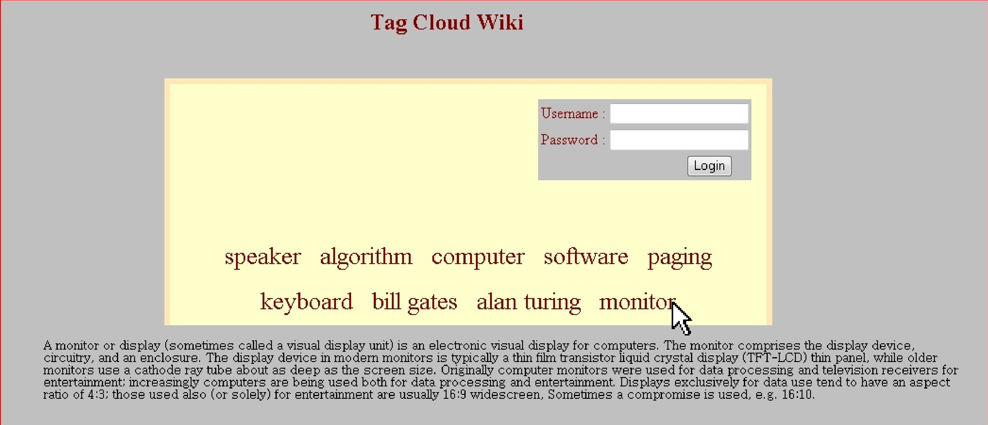

USER PAGE: after user is logged-in.
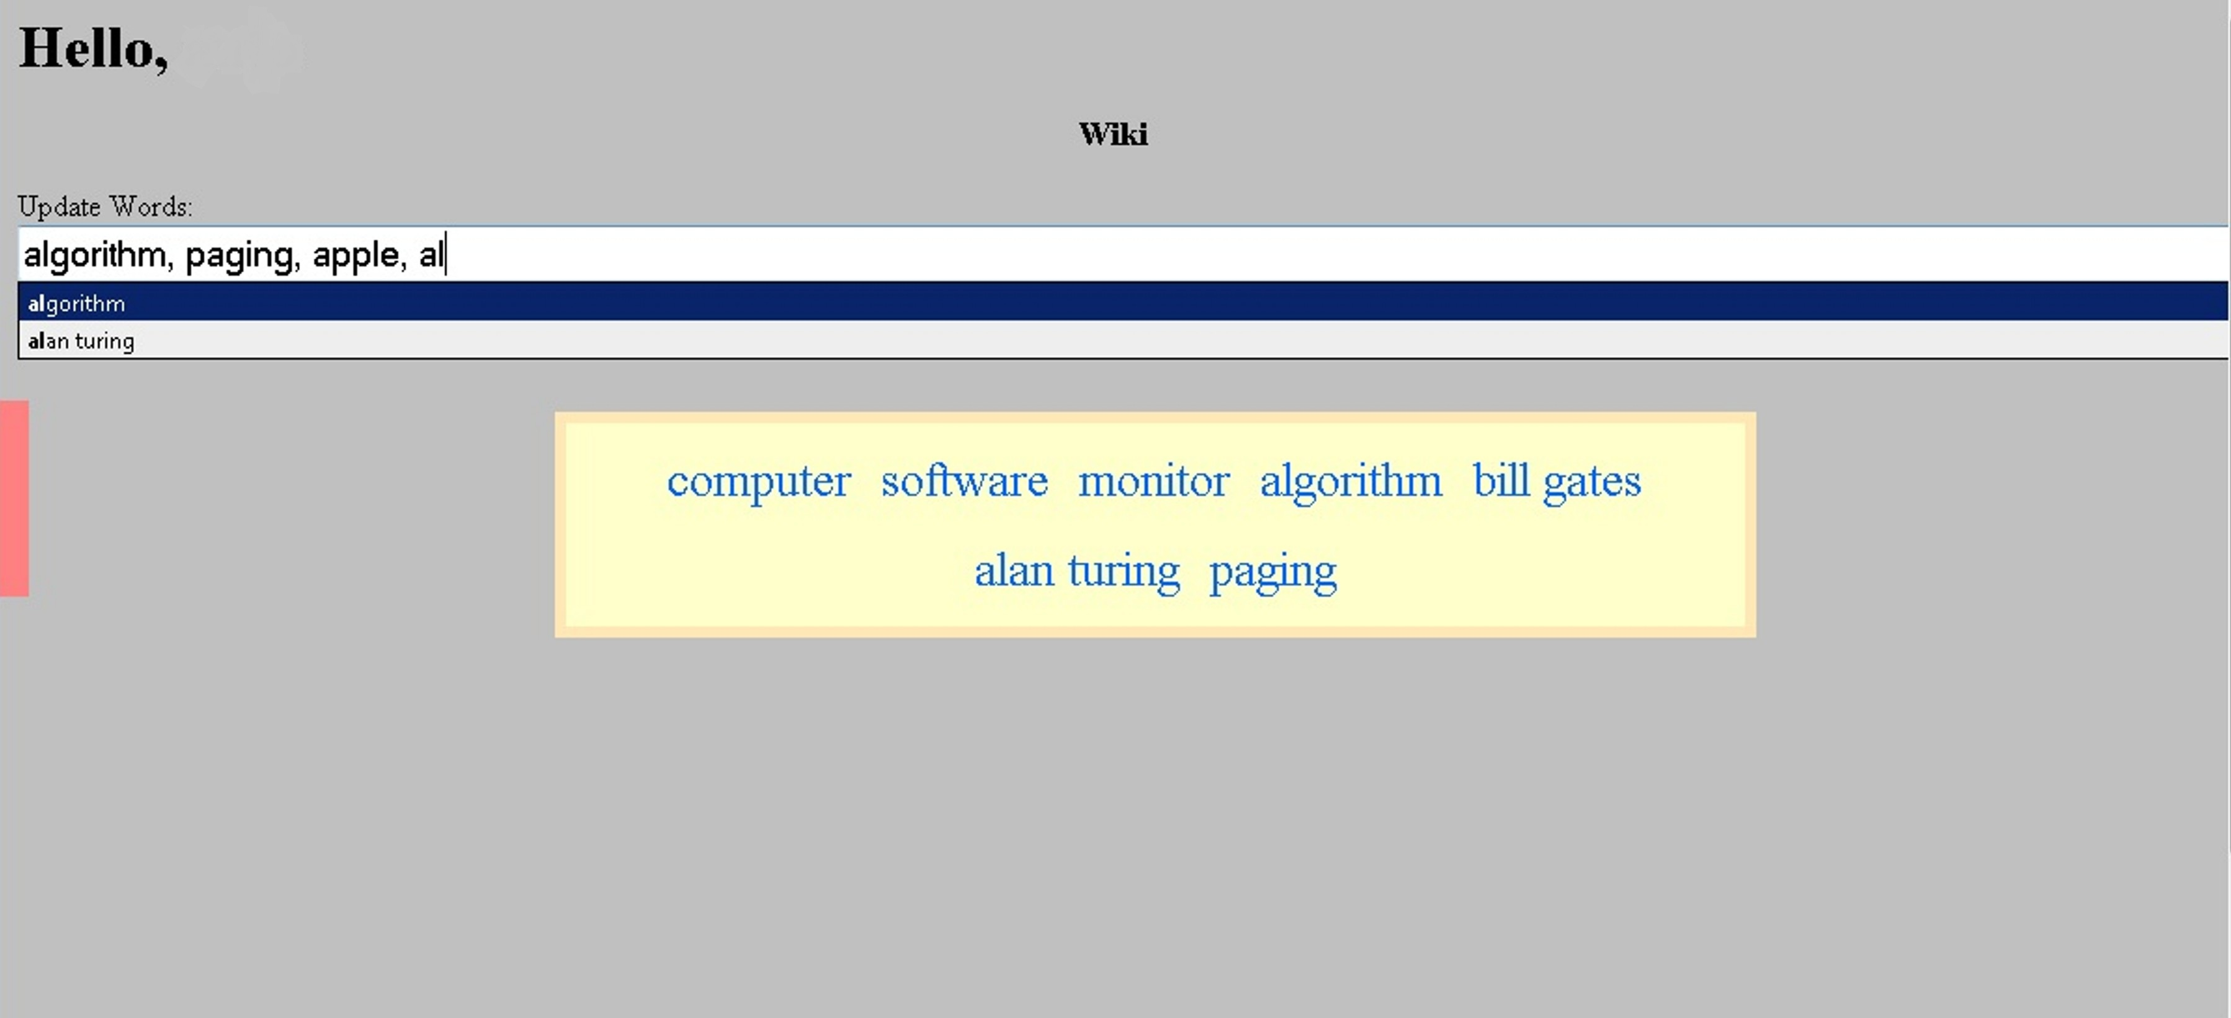

MENU WITH USER’S TAG CLOUD
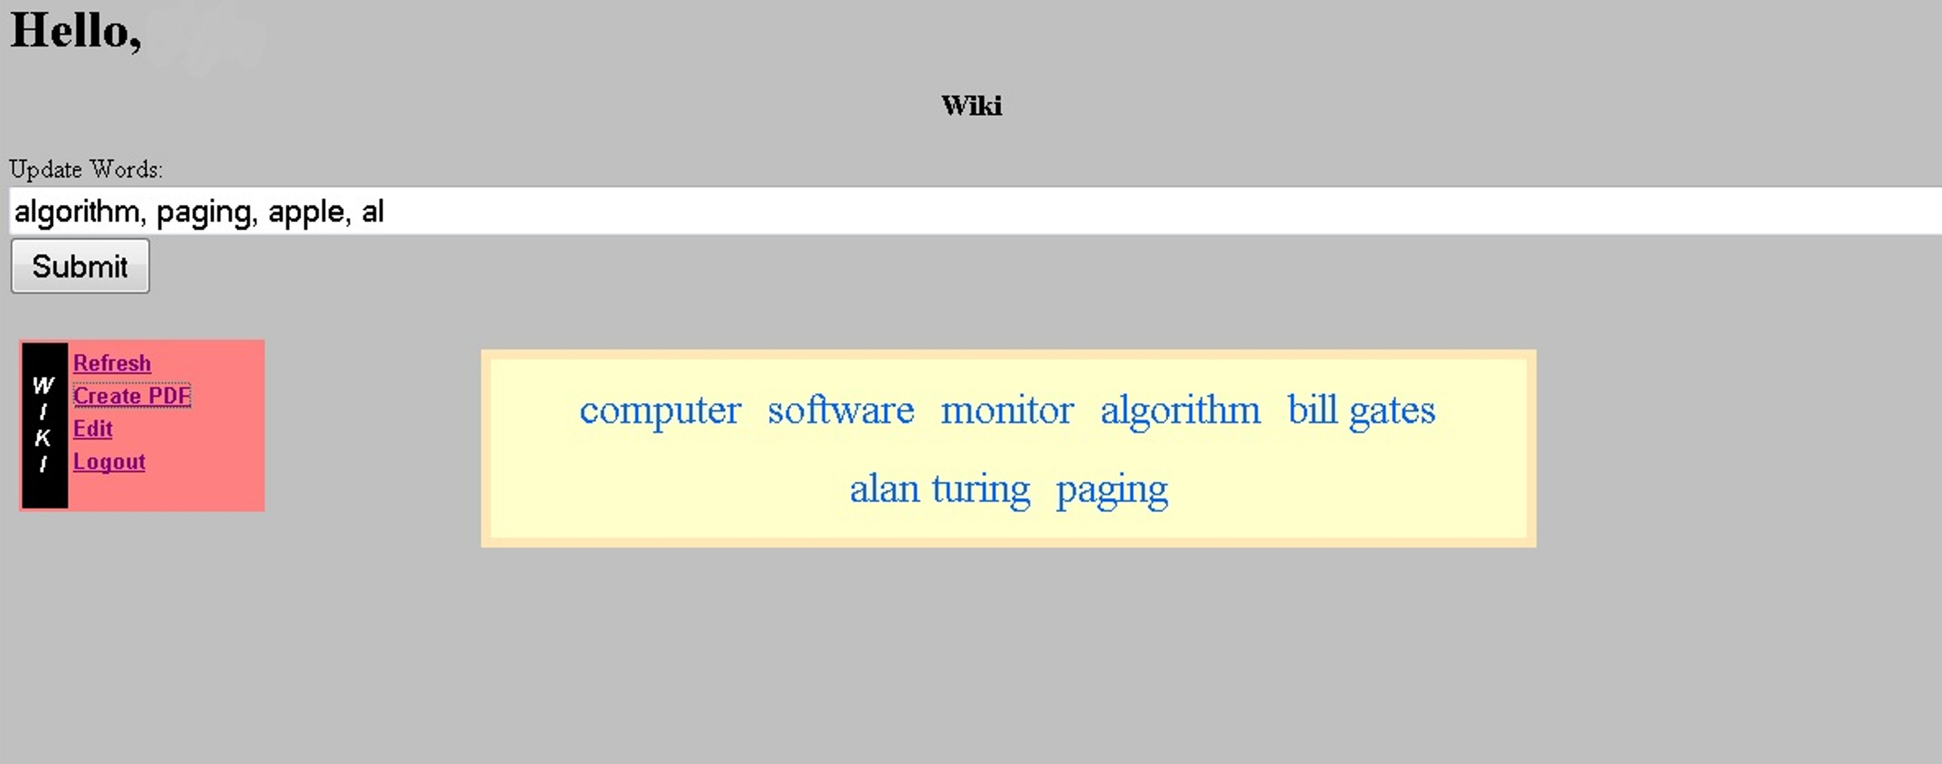

EDIT WORD:

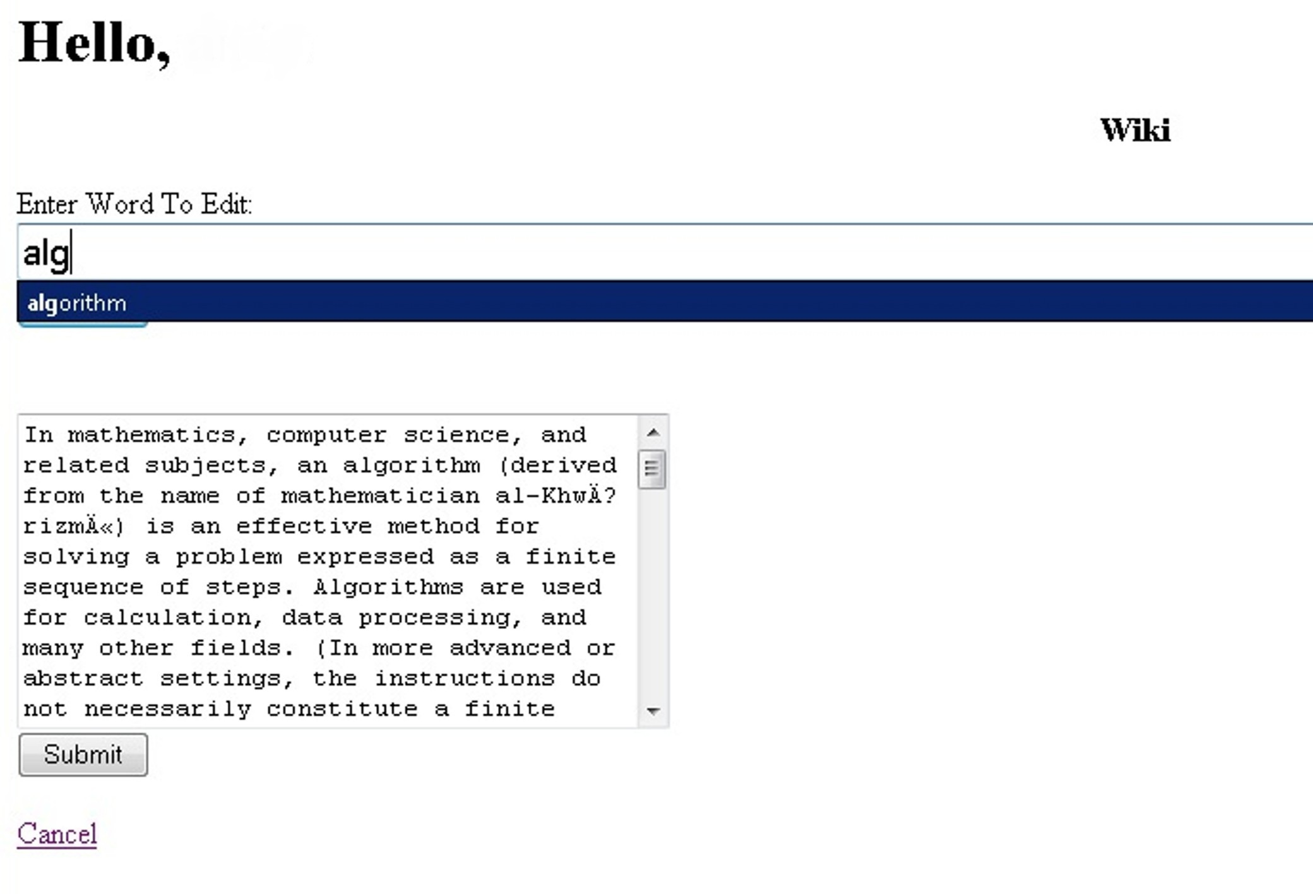

SAMPLE PDF:

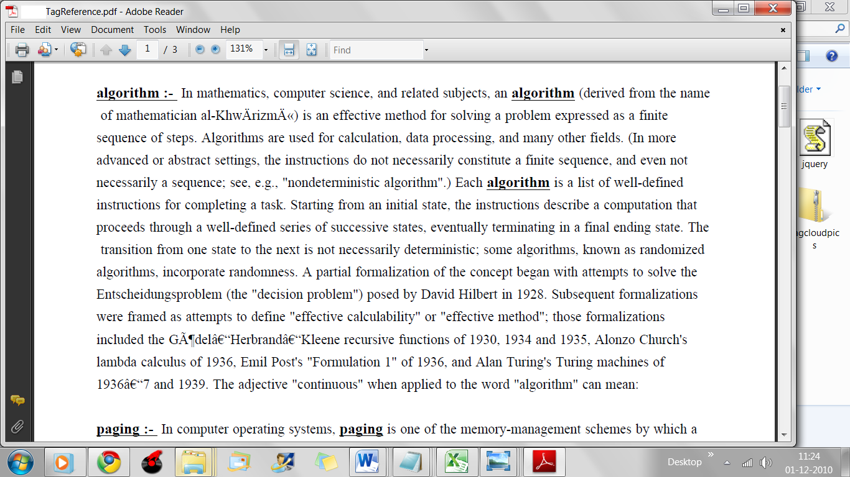

5: FUTURE ENHANCEMENTS

- This project can be enhanced to extract information from other sources too and not only limit to Wikipedia.
- It can be expanded to suit a variety of end users.
- It can be made more smart and intelligent.
- Can implement more tag clouds for a single users.
- We can implement an E-mail function where the user receives updates about his words and other words searched.

BIBLIOGRAPHY
- ITEXT – JAVA LIBRARY FOR AUTOMATED PDF CREATION
www.itextpdf.com
- www.W3schools.com : Tutorials on HTML, CSS style sheets, JavaScript.
- www.wikipedia.com

